|  |
| --- |
| Image containing furniture, table, drawing, flower  Auto-generated description**Practical work Devices E.** |

|  |  |
| --- | --- |
| **GROUP N°--------------** | **COURSE:R3031** |

|  |
| --- |
| **PROFESSORS: Ricardo Alberto Zuazquita and Eduardo Víctor Oreglia** |

|  |
| --- |
| **ATTEND DAYS: Monday and Friday** |

|  |
| --- |
| **ON DUTY: Afternoon** |

|  |
| --- |
| **PRACTICAL WORK N°: 1** |

|  |
| --- |
| **TITLE: Comprehensive Simulation and Analysis of Diodes (PN, Zener & Schottky) in LT-Spice.** |

|  |
| --- |
| **Student: Costarelli Facundo Lautaro** |
| **DNI: 42.724.683** |
| **File: 176.291-6** |

|  |  |  |
| --- | --- | --- |
|  | **DATES** | **SIGNATURE AND CLARIFICATION OF THE TEACHER** |
| **CARRIED OUT ON** | 31/05/2024 |  |
| **CORRECTED** |  |  |
| **APPROVED** |  |  |

|  |
| --- |
| **INDICATIONS FOR CORRECTIONS:** |

**Index**

1. Introduction -------------------------------------------------- Page 1
2. Development ----------------------------------------------------- Page 2

i. Characteristic curve of the diode ----------------------- Pag 2  
Ii. Diode resistors -------------------------------- Pag 10  
Iii. Diode Junction and Diffusion Capabilities -------- Page 12

1. Conclusion ---------------------------------------------------- Page 29

**Introduction**

In the work presented, it seeks to study the real behavior of the diode starting with a typical common 1N4148 as well as a Zener diode BZX84C5V6 or equivalent and a Schottky diode 1N5819. In the 3 cases, it is sought to evaluate their current responses, special functionalities and some advantages and disadvantages when applying a direct and reverse polarization with a direct source of continuous.

While for the 1N4148 diode, in addition to the above, it is sought to study and obtain its dynamic resistance for a sine wave variable voltage with also the current response for this signal as well as for a square signal.

The LT-Spice is used as software for simulating circuits, measuring and graphing the results. The conclusions that will be obtained will be very useful to understand how electronic devices work in a more real way as well as the theoretical concepts associated with them and learned in class.

**Development**

1. i. *Diode characteristic curve*

a) By making the following circuit where the temperatures chosen are those proposed in class for both item a) and b). The diode to be used is a common 1N4148 library with the internal data by default. We see the resulting graph as well:

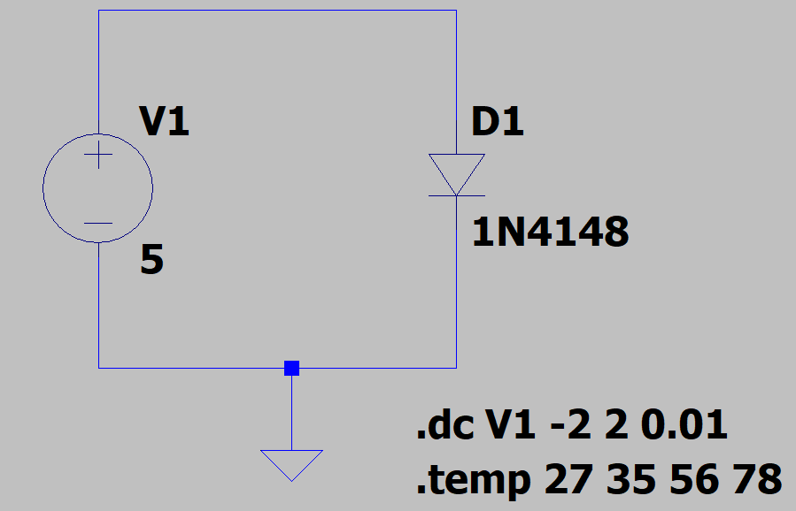

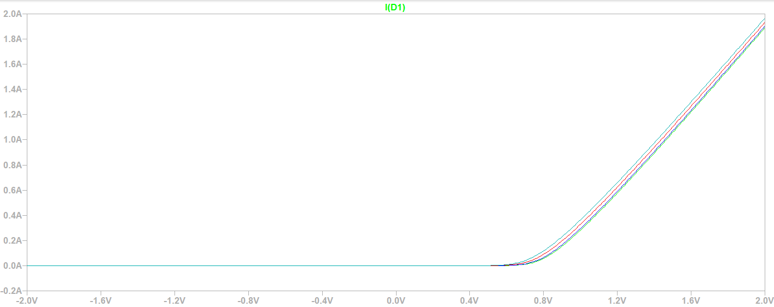

It can be observed that in forward polarization the diode conducts where the threshold voltage for which a significant current begins to conduct is from 0.7 V to 0.8 V, where the current has an exponential behavior such that it increases rapidly as the voltage increases. Conversely, it ideally does not conduct since the saturation current is very small and negligible. In particular with temperature, as it increases, the current grows faster and in greater quantity for the same voltage value comparing between two or more curves. This is because the increase in temperature implies an increase in electron-lagoon pairs of mobile carriers that contribute to the increase in direct current. In addition, the curve graphically grows faster exponentially. That is, the celestial curve for 78°C is exponentially faster than the green curve for 25°C. The maximum forward current "Id" appreciable in the graph is at 2 A and 2 V. For values greater than 1 V, the curves are linearized despite following an exponential behavior.

Zooming in, we see that when evaluating the cursor between two graphs, for example the light blue and the blue, for the same analysis threshold voltage of 650 mV, there are two very different current values.

In green curve for 650 mV there is 4 mA approx with temp = 27 °C.

In celestial curve for 650 mV there is 20 mA approx with temp = 78 °C.

The greater the difference in temperature between the first green curve and the others, we see that there is a greater increase in the current and in a faster and more noticeable way.

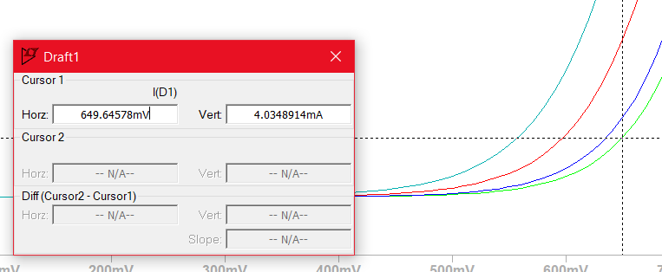

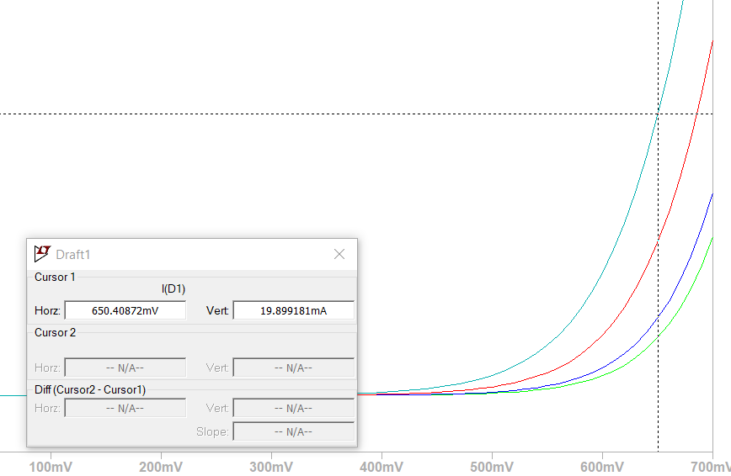

b) The same configurations and circuit are used as in 2 a) with the addition of a .t directive where it is: .model 1N4148 D(Is=700n Rs=.568 N=1.752 Cjo=4p M=.4 tt=20n Iave=200m Vpk=75 mfg=OnSemi type=silicon). This was extracted from the database and only modified Is such that it is now 700 nA. We see the graph:

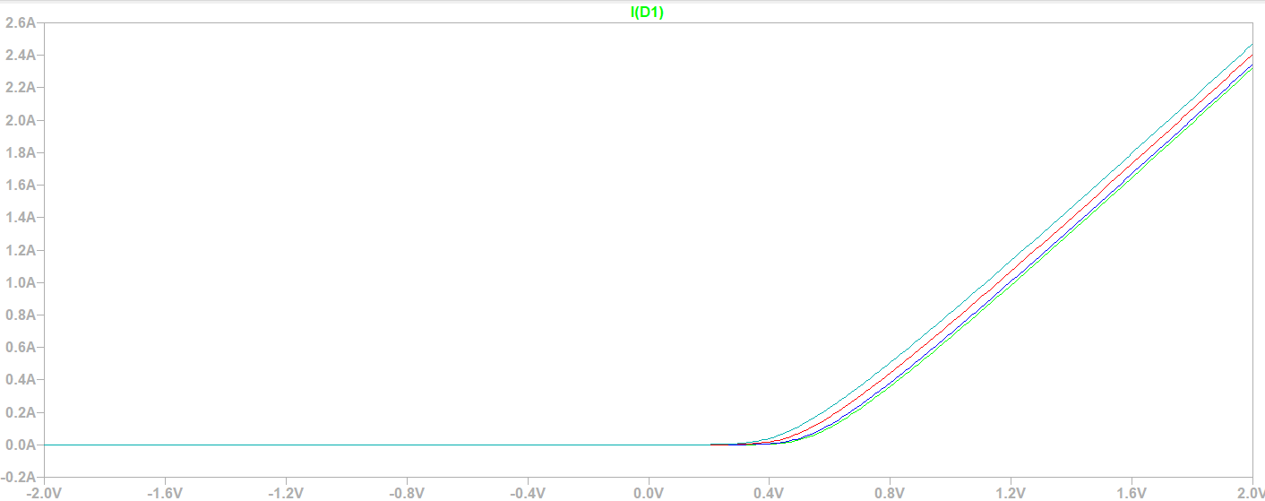

Regarding 2 a) the idea is maintained that, as the temperature increases, the current grows much and rapidly exponentially for the same voltage value between all the curves due to the increase in pairs of moving carriers. What is new is that for all voltage values, especially those close to the origin, there is more current, i.e. the diode conducts more directly than before. In addition, it increases the range of direct currents that the diode can reach for each temperature and the maximum value of Id that each curve can take for example 2 V. Again in reverse it does not conduct and the saturation current is very small.

On the other hand, the curves for different temperatures are more exponential between 0.3 V and 0.8 V but at values greater than 0.8 V, the curves begin to linearize such that the current has a more linear behavior.

c) For this point, a Zener with a BZX84C5V6 statement is analyzed, but it is replaced by a similar one given as a BZX85C6V2L since the one with a statement is not in the Lt-Spice library. The temperatures were set again with a different range than 2 a) and 2 b) but where the circuit is the same. For this diode it will be observed that it conducts both in direct and reverse, conducts exponentially once the threshold voltage in direct has been exceeded and the breakdown voltage in reverse has been exceeded. In direct it is very similar to points 2 a) and 2 b) the shape of the curve, its behavior and causes since a Zener diode behaves like a common diode in direct. We see the circuit and the graph:

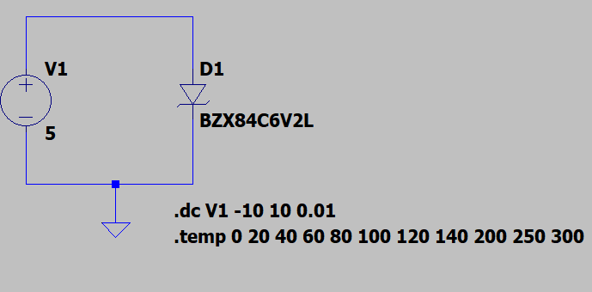

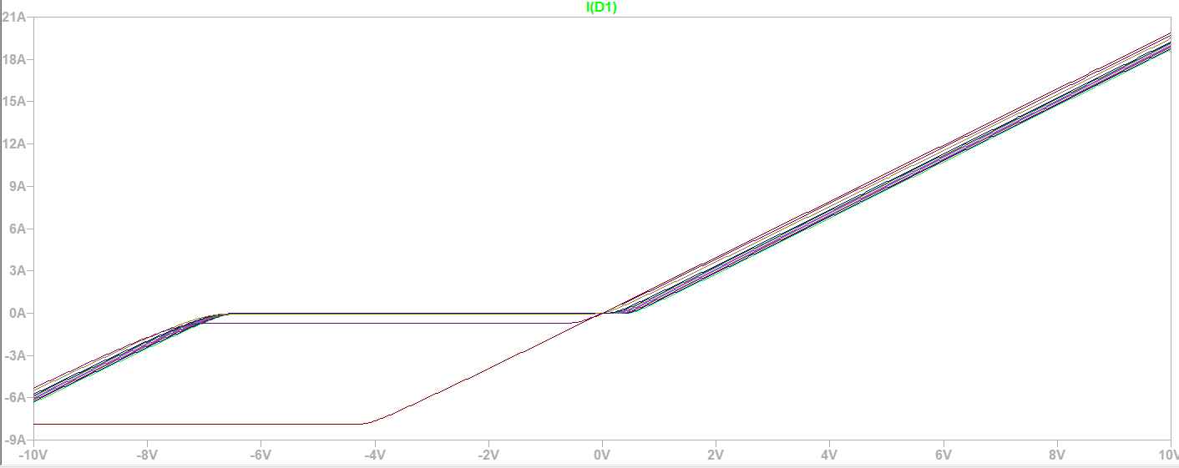

In particular, analyzing in reverse with the directive: .dc V1 -20 0 0.01 and zooming in we see the graph:

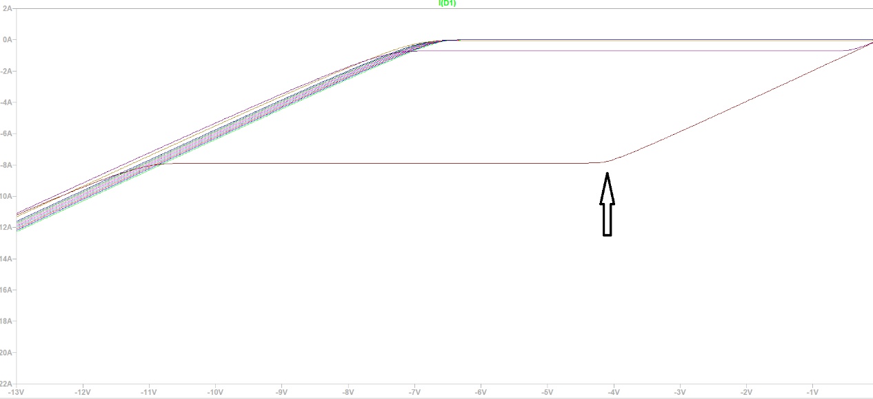

We will say that the breakdown voltage varies with the temperature, if this increases then the breakdown Vz decreases because if the temperature increases then the thermal energy increases, therefore, the kinetic energy and as a result the number of electron-lagoon pairs. In addition, each electron is more likely to acquire enough energy to jump from the valence band to the conduction band, thus increasing the current.

From the graph we see that when the Is of a Zener diode is increased, the avalanche effect decreases. But when Is decreases, the avalanche effect becomes more noticeable. The Zener diode can conduct more current in the rupture region, faster and in much larger quantities than directly. It is also more prone to overcurrent damage.

You can see a very different curve with respect to the set, which is the one marked with an arrow, which corresponds to T = 300° where for a voltage close to 0 Volt, it conducts a lot of current Is in an almost linear way since it is actually an exponential behavior with a very negative and large slope. It then remains almost cte during a range of negative voltages and then resumes the initial form of reverse mentioned from another value of reverse voltage where it continues to increase the current a lot and very quickly.

d) A circuit is configured with a 1N5819 Schottky diode as the following, which will give a series of curves as the following image. The default Is is 31.7 au for this analysis.

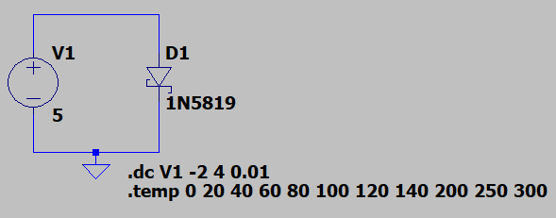

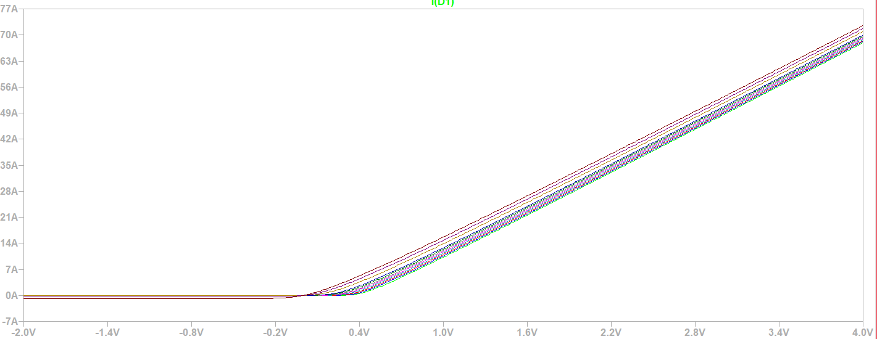

Zooming in a little more and analyzing with the cursor at one point we have:

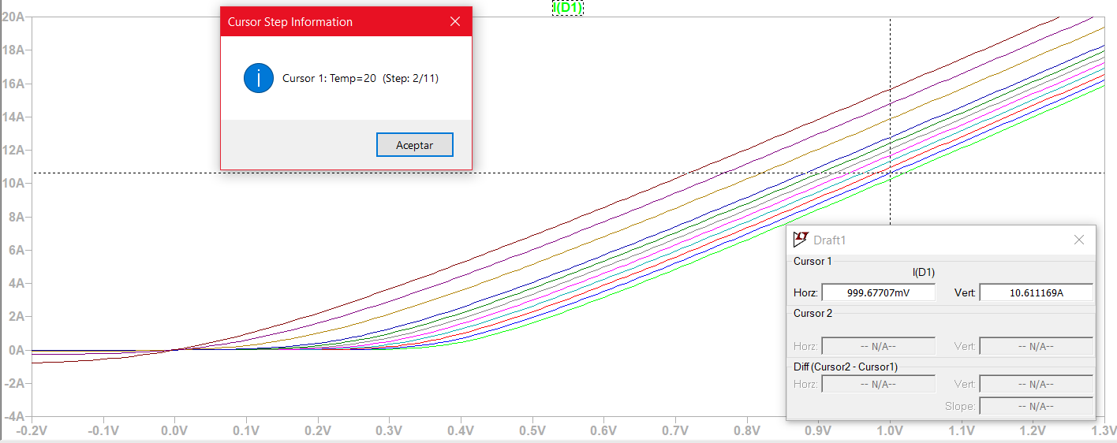

You can see that in a Schottky diode, the voltage for which it conducts current significantly, i.e., the threshold voltage is between 0.1 Volt and 0.4 Volt for different temperatures. This threshold voltage is lower than that of a common PN diode, allowing for higher switching speed and better system efficiency.

The notable difference between a Schottky diode and a PN diode is that, in forward polarization, the Schottky diode with a low voltage drop can conduct high amounts of currents. For example, for 1 Volt we see that the current is between 10 and 15 A for all the chosen temperatures. In particular, for 20°C with 1 Volt of forward voltage, we have 10.6 Amper approximately which is quite current.

Now changing the Is to 40 mA and using the same circuit we see the following graph:

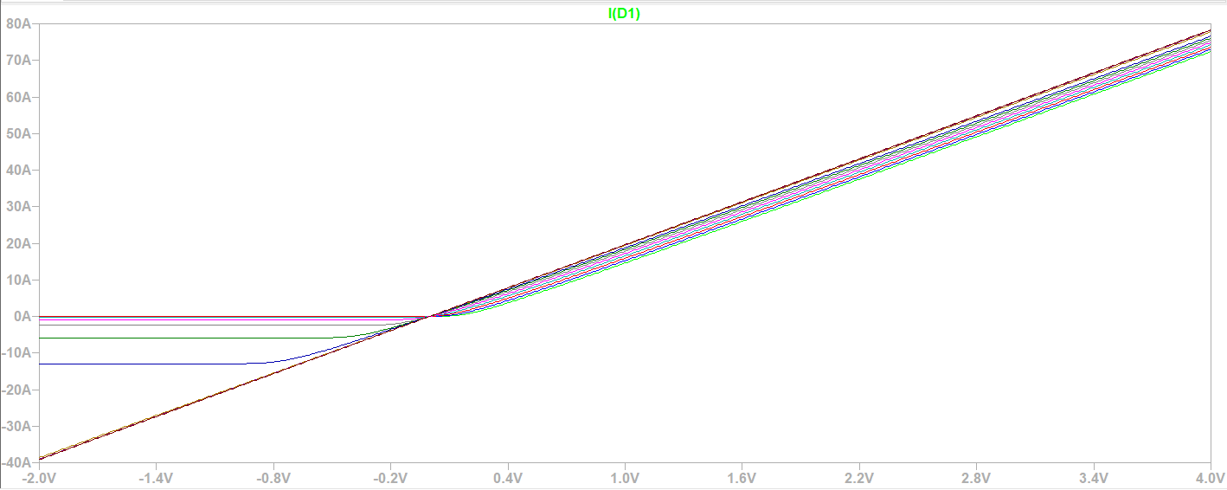

Zooming in we have the following:

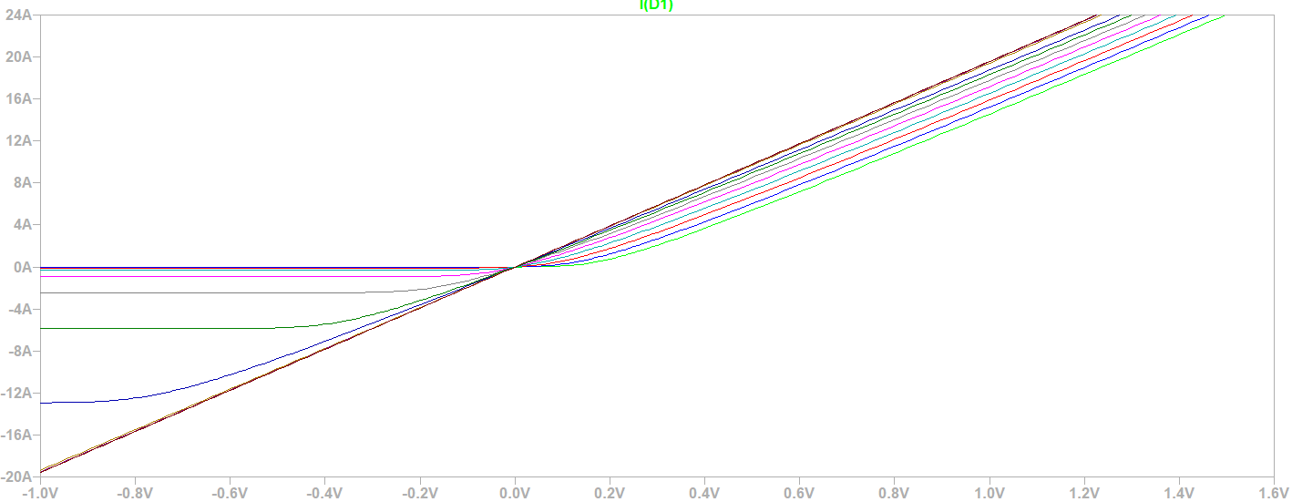

When we change the current Is, in particular increasing it, it can be seen that the potential barrier of the junction tends to decrease resulting in more direct current conducted for lower polarization voltage values. This allows for less energy loss. It also causes an increase in switching speed, which is useful for high-frequency circuits to rectify radio frequency signals. Finally, the increase in Is results in an increase in reverse leakage currents, which is unwanted since these currents are reverse leakage. In addition, if we increase the temperature, we see that for each curve the reverse leakage current increases.

From the following image with the cursor we see that the analyzed curve corresponds to 20 ° C with 1 Volt of direct voltage, we have 15.2 Amper approximately with respect to the case of Is by default. That is, with the new Is, it is clearly seen that the current for the same forward bias voltage increased much more.

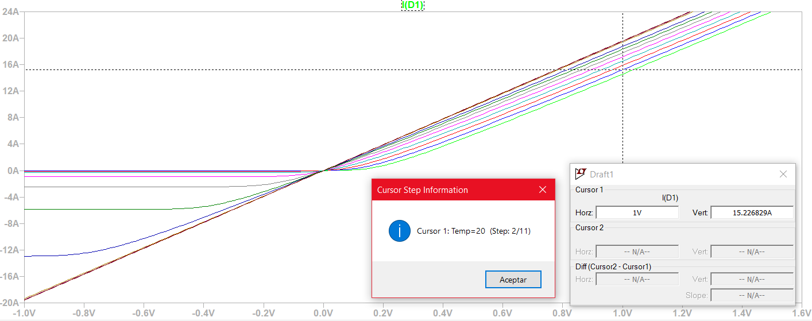

2) ii. *Diode resistors*   
With the following circuit using a 1N4148 diode and with the configurations shown we see the study curves:

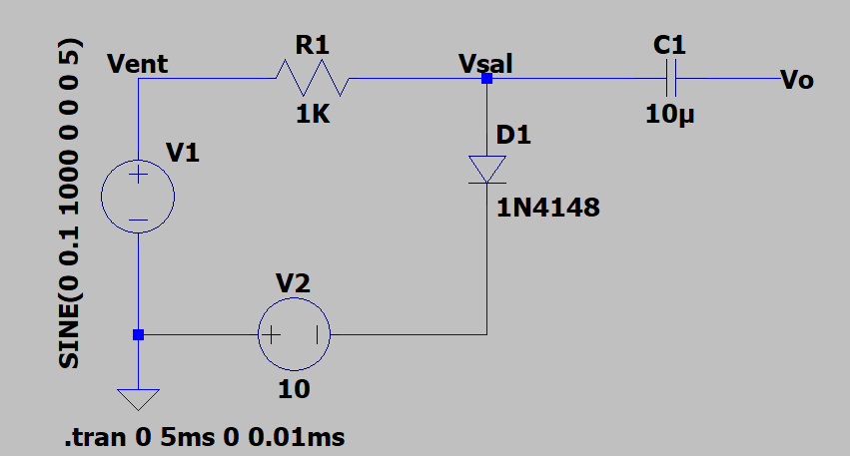

Vent Input Sign:

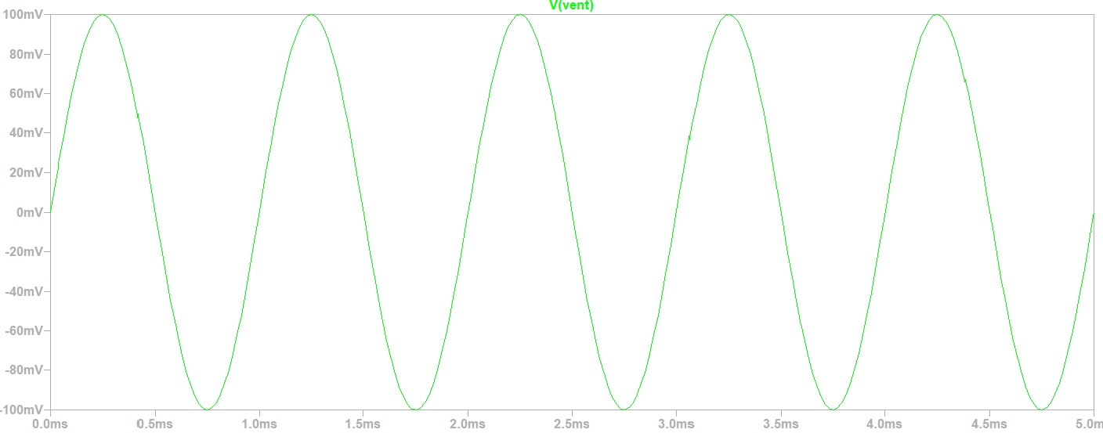

Output signal "Vsal" on node joining R1, D1 and C1:

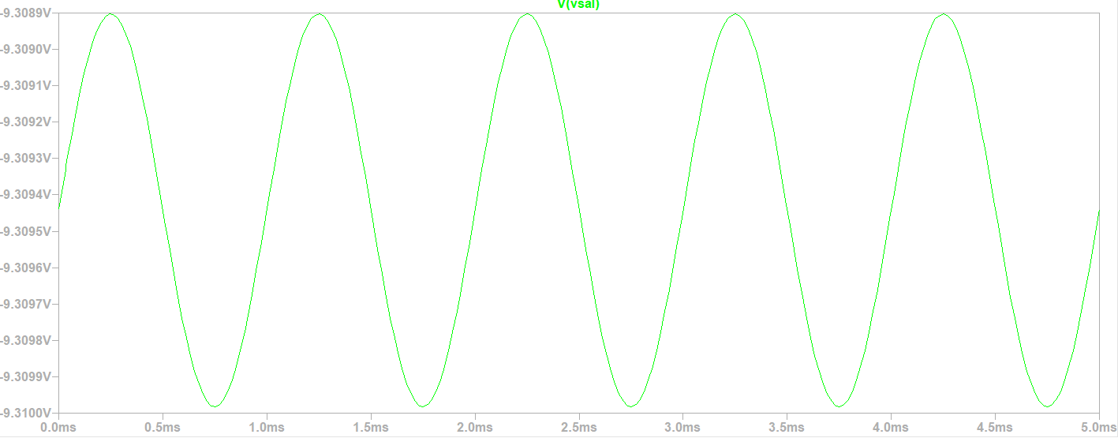

Output signal "Vo" at the output of C1:

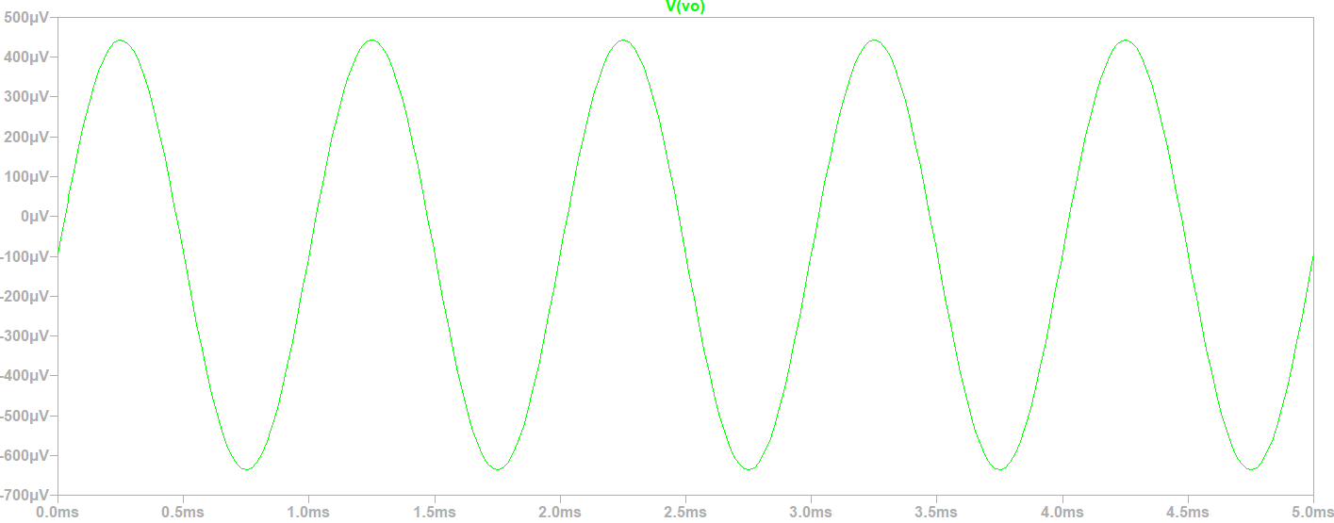

a) The graph of the Vent signal shows that the alternating sine input signal is not affected in phase, amplitude or morphology by the V2 continuous source. This is because for the AC circuit, the DC source behaves like a closed wire or key since , which means that because it is a cte and that results in Rv2, alternating = 0 which is equivalent to a closed cable or key. Similarly, for the DC circuit, the AC source behaves like a closed cable or key since its DC component is null; but if it had, then it would behave like a generator whose voltage is the DC component of that AC generator.

On the other hand, the presence of the C1 capacitor causes the sine sine alternating signal in Vsal, resulting from the circuit with the diode and the resistor, to be affected, producing a significant attenuation in the amplitude, as well as a phase change where it temporarily delays it, this when measured in Vo.

b) From the graphs, Vo = 450μV amplitude and Vent = 100mV amplitude with R1 = 1K Ω. Applying the voltage divider method using the amplitude values or peak values mentioned above, we have that:

Vo = Vent. where rd = = 4.52Ω

The "rd" is the dynamic resistance of the diode, this is the resistance to the passage of variable current in time i(t) in the diode when it is subjected to a variable bias voltage in time vd(t).

2) iii. *Diode Junction and Diffusion Capabilities*

a) **Analysis for input signal as a pulse train with default values of junction and diffusion capacity**:

We see the response of the 1N4148 diode in the current for the pulse-type source V1 whose frequency ranges from 1 MHz to 5 MHz. We consider a Cj = 4 pF and Cd associated with tt = 20 nsec, both by default:From the following circuit configuration I study the following curves:

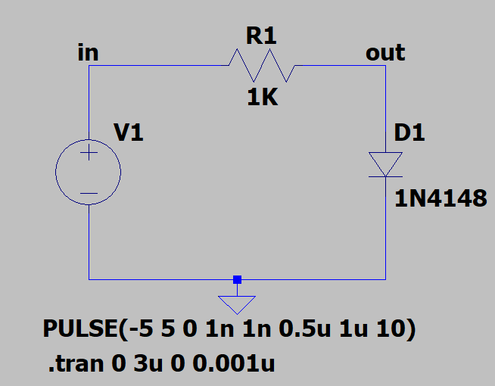

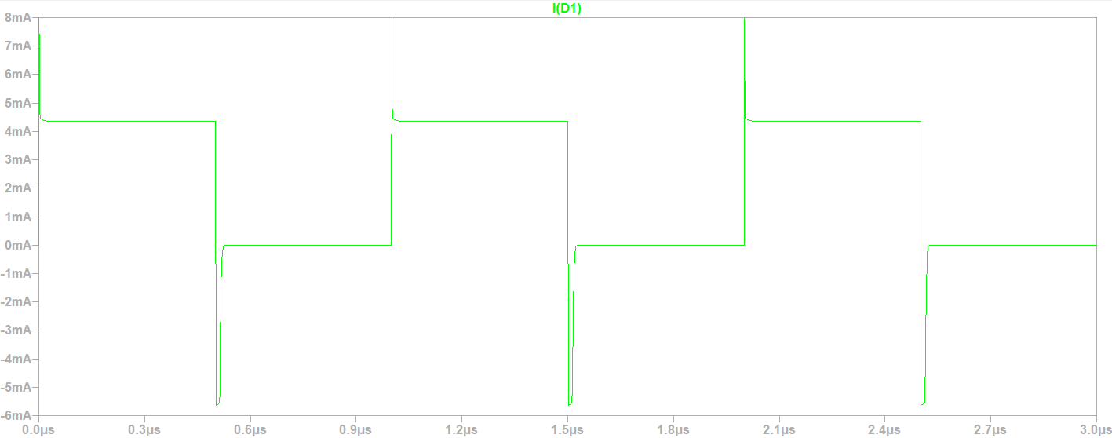

We observe that at the exit, and even in the input signal, current peaks appear in the jumps between one step and another of the pulse train. This is because ideally the pulse train is a step train where the changes between the height of one step and another is so fast that ideally it is an instantaneous jump represented by a vertical line which refers to a 0 jump time. For the Lt-Spice it is necessary to indicate a target time of 0, we take 1n second as a reference for each peak.

On the other hand, we see that in the positive half-cycle associated with forward polarization, the diode reaches a voltage higher than the threshold voltage, which results in current conduction where a peak of this magnitude is seen every time we go from a negative semi-cycle of inverse to a positive half-cycle of direct. After the peak, the current is maintained in the direct semi-cycle due to the nature of the square signal or pulse train.

But when studying the negative half-cycle associated with the reverse polarization, we see that a peak of reverse leakage current appears rapidly until it reaches a maximum negative value such that then the peak returns to 0 abruptly. This occurs when going from a direct half-cycle to a reverse one. After the peak reverse leakage current returns to 0, we see that the signal remains cte and null for the rest of the reverse half-cycle. This is because the diode, in the given configuration, "clips" or "rectifies" the negative half-cycles of the input signal.

**It is possible to conclude** that a diode at low frequencies, such as 50 Hz, can work as a rectifier, although it is not perfect since for a short time it conducts in reverse, that is, it allows a small part of the negative half-cycle of an alternating signal to pass through. This effect would be negligible at low frequencies. However, increasing the working frequency, such as 1MHz, would produce this undesired effect to a greater extent, which would not be useful and would be more noticeable in RF (Radio Frequency) circuits, introducing distortions and noises.

b) **Analysis for input signal as a pulse train varying the joining capacity**:

We start with the following directive ".model 1N4148 D(Is=2.52n Rs=.568 N=1.752 Cjo=4p M=.4 tt=20n Iave=200m Vpk=75 mfg=OnSemi type=silicon)" to modify the diode parameters. Remembering that the default value of the junction capacity is Cj = 4 pF. Without changing the diffusion capacity, but changing the value of the junction capacity 5 times in 5 different values, we have the following graphs:

For Cj = 0.01 pF

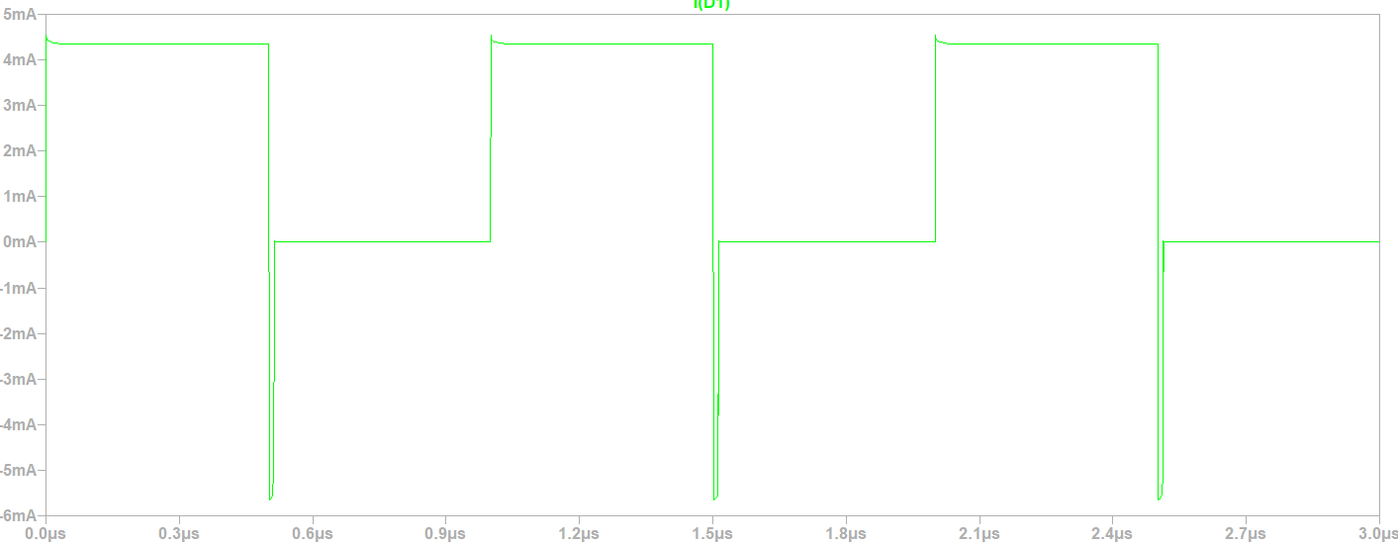

For Cj = 1 pF

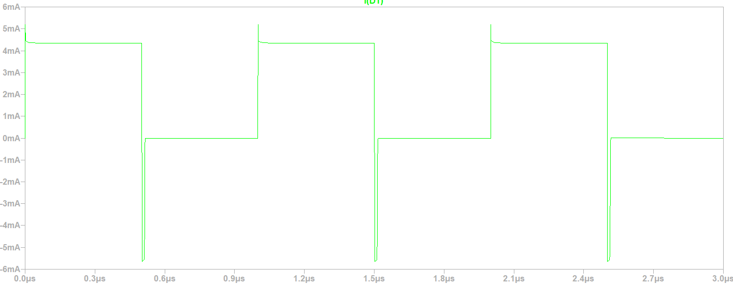

For Cj = 20 pF

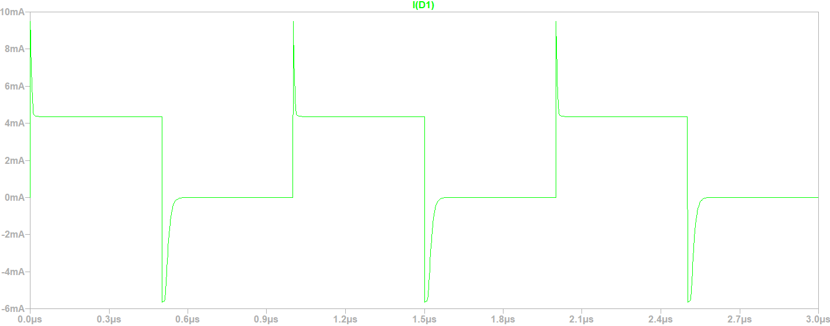

For Cj = 100 pf

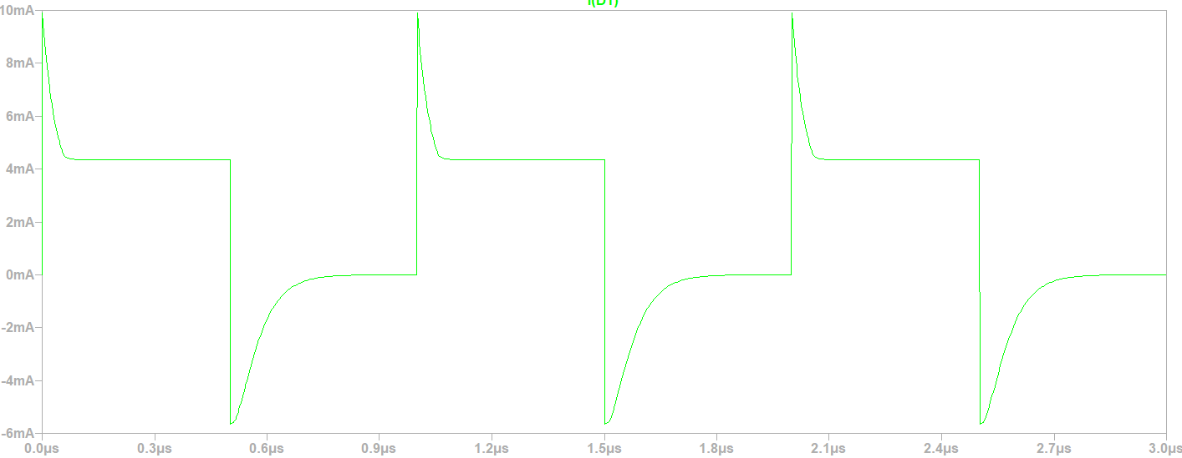

For Cj = 1 nF

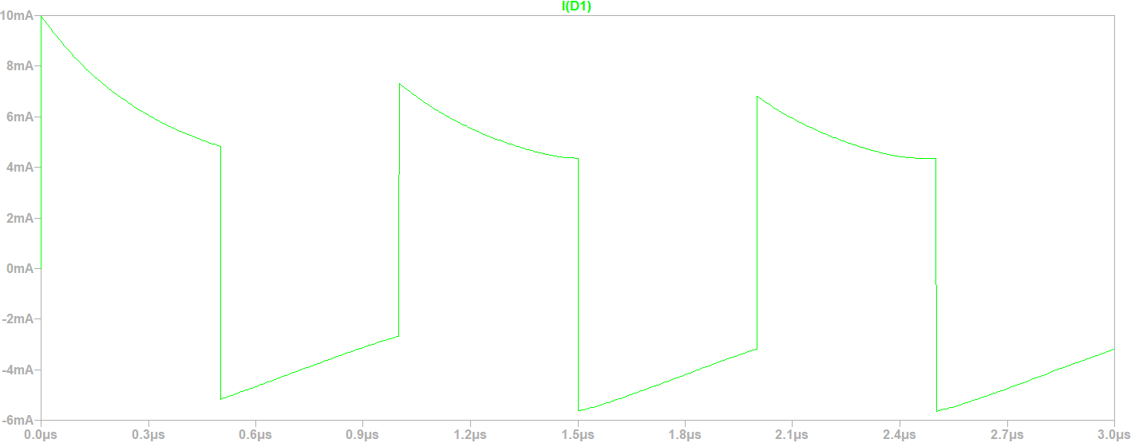

We see that for junction capacities Cj less than the default of 4 pF as an example Cj = 0.01 pF and Cj = 1 pF, the current peaks decrease in amplitude and duration between positive half-cycle changes from direct to negative to inverse and vice versa. This is that we will have a perfect rectifier diode if Cj 0, thus cutting the negative half-cycles of the signal and only letting the positive half-cycles pass, although there will be current peaks in the shape of a linear line with an infinite slope.

However, for values higher than 4 pF by default such as example Cj = 20 pF, Cj = 100 pF and Cj = 1 nF, it is concluded that current peaks increase in amplitude and duration. In particular, when going from a negative to a positive half-cycle, this peak reproduces the current discharge curve of a typical capacitor such as the electrolytic or the ceramic capacitor with parallel flat plates. Likewise, when going from a positive to a negative semi-cycle, the peak reproduces the current charge curve of a usual electrolytic or ceramic capacitor, that is, of parallel flat plates again. This capacitor in this case is the one formed at the PN junction but with the difference that the charge is not stored on flat plates but in volume associated with transition zone P and N, each separately. In addition, this capacity varies according to the width "l" of the spatial load zone, which is not fixed and varies according to the alternating polarization voltage. It would be fixed if the polarization was with a DC source but the pulse train signal is alternated. All this implies that if the Cj ∞ then the diode does not work as a rectifier, but allows the entire input signal to pass through without rectifying it at all and where the current peaks, produced in the passage from one semicycle to another, disappear as the discharge and charge curves of the junction capacitor are linearized.

**In conclusion**, the diode for low junction capacities tends to be a perfect negative half-cycle rectifier by letting positive half-cycles through, albeit with infinite-slope current peaks. Whereas, for high junction capacity, the diode simply does not function as a diode but as a closed key or cable which could be confused with it being in poor condition or broken, but it would not necessarily be that. This is evaluating at high frequencies as an example 1 MHz to 5 MHz.

c) **Analysis for input signal as a pulse train varying the diffusion capacity**:

We start with the following directive ".model 1N4148 D(Is=2.52n Rs=.568 N=1.752 Cjo=4p M=.4 tt=20n Iave=200m Vpk=75 mfg=OnSemi type=silicon)" to modify the diode parameters. Remembering that the default value of the diffusion capacity is Cd associated with tt = 20 n sec. Without changing the junction capacity, but changing the value of the diffusion capacity through the tt about 5 times in 5 different values, we have the following graphs:

For tt = 0.01 n sec

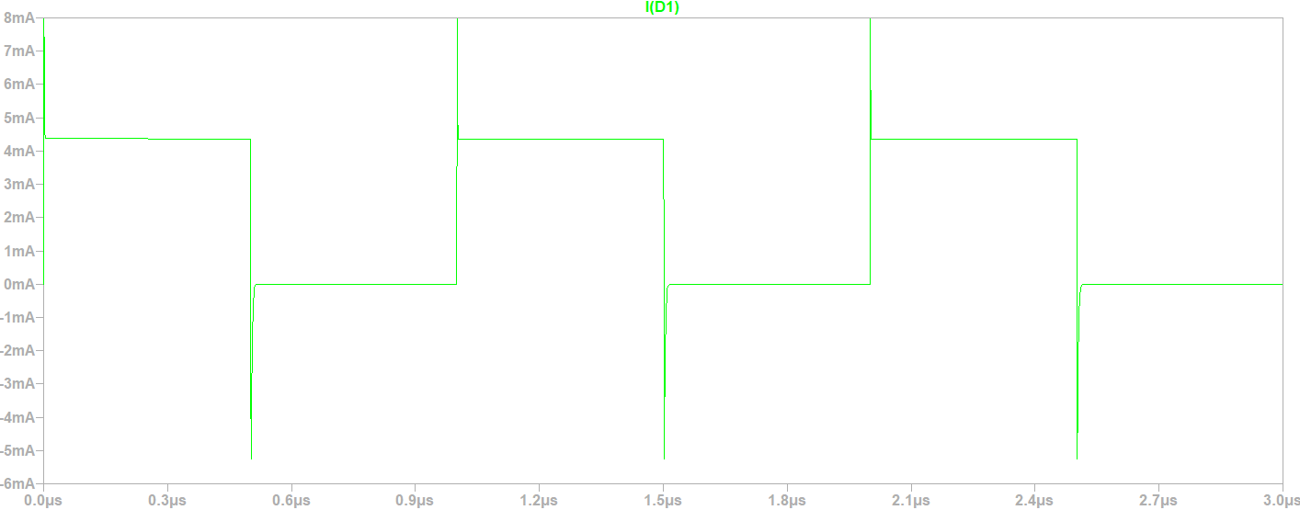

For tt = 1 n sec

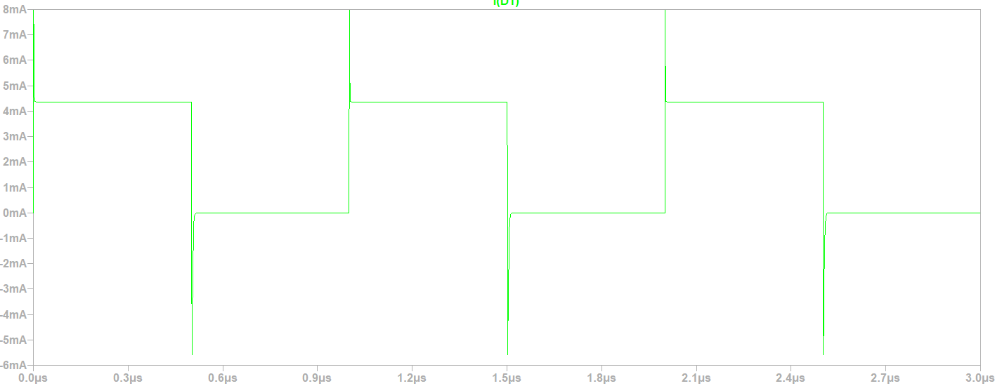

For tt = 100 n sec

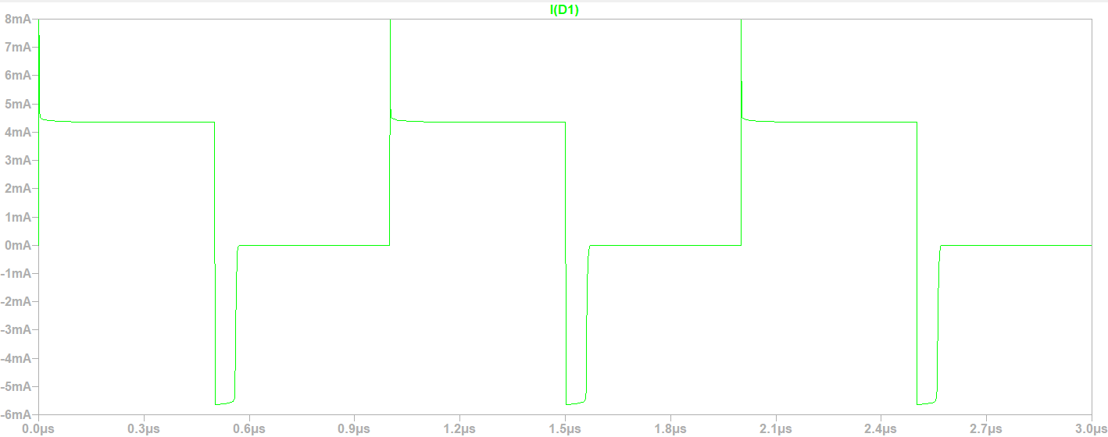

For tt = 500 n sec

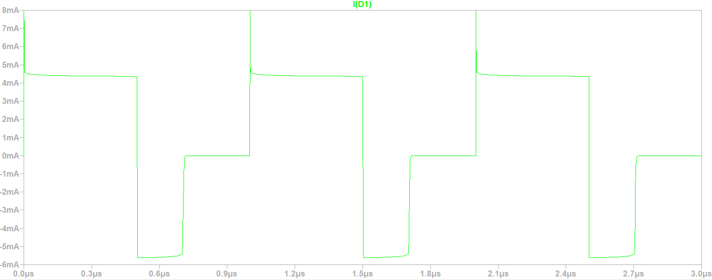

For tt = 1000 n sec

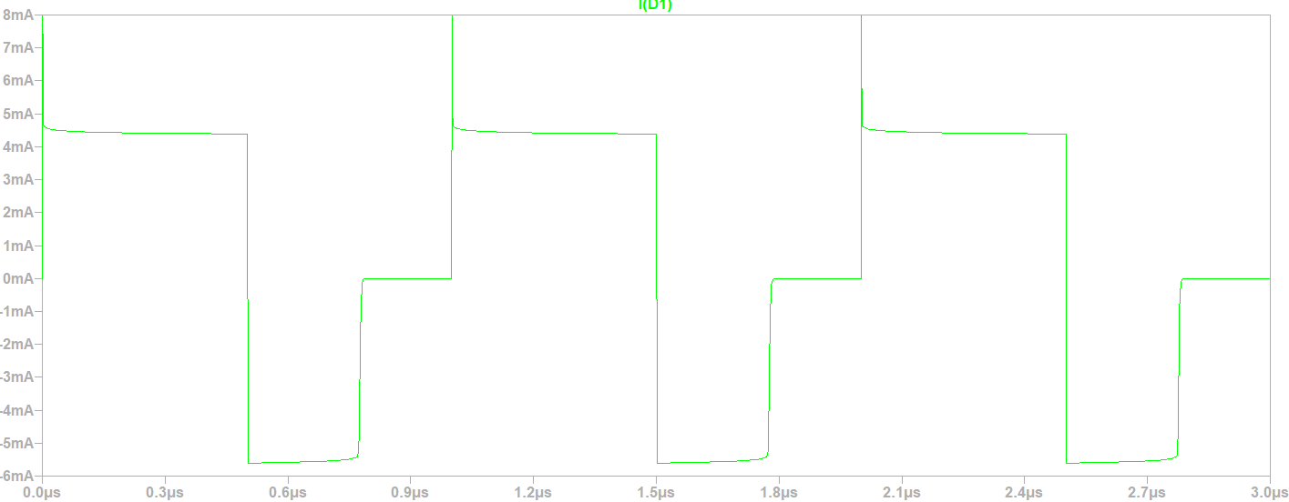

We see that for all the values of "tt", transition times each associated with a different diffusion capacity, infinite slope current peaks appear when we go from a negative half-cycle of reverse polarization to a positive one of direct polarization. This peak has a large amplitude and a very short duration time for all cases. But when we go from a positive half-cycle of direct bias to a negative one of reverse polarization, there are also peaks of reverse leakage current such that they represent capacitor load curves, but where these are almost linear, very fast and of almost infinite slope, being that the graphs are like square or rectangular pulses of reverse voltage of different duration times or duty cycle, but all with the same amplitude. In this case, capacitor formed by the variation of accumulation of charges in volume in the neutral zones where this variation is subject to the diffusion process, i.e., recombination of excess minority carriers from the area in which they were the majority and that now crossed the spatial charge zone, becoming minority and diffusing in the neutral zone of arrival.

In particular, for "tt" less than tt = 20 n sec by default, it happens that the reverse current peak has a large amplitude, but a very short duration time such that the reverse pulse it represented is negligible. Thus, the diode only conducts in the direct half-cycle and does not conduct in the reverse half-cycle by "clipping" or rectifying the signal in its negative half-cycles.

On the other hand, for values of "tt" greater than tt = 20 n sec by default, it is observed that the peak of inverse current reduces its amplitude until it almost equals in modulus the amplitude of the high state of the positive half-cycle. In turn, the inverse duty cycle extends and increases as "tt" increases, i.e., when the diffusion capacity increases. This results in a square or rectangular pulse of near-constant modulus amplitude equal to the amplitude of the positive half-cycle, but with a certain duration. Then this pulse disappears and the diode "clips" or rectifies the rest of the negative half-cycle signal until it jumps to the positive half-cycle.

We can think as a **conclusion** that as the diffusion capacity, through "tt", is reduced, then the diode behaves like a rectifier and especially if it tends to 0 that "tt" then it is a perfect rectifier. While when "tt" increases, i.e. increases the diffusion capacity, then the diode behaves as a regulator of the duty cycle of a periodic square signal in reverse polarization and that does not modify the duty cycle of the pulse of the positive half-cycle, it only does so for the pulse of the reverse half-cycle. Although very short-lived transient current peaks appear at the beginning of each positive half-cycle. This is evaluated at high frequencies, such as 1 MHz to 5 MHz.

a) **Analysis for input signal as sine with default values of junction and diffusion capacity**:

We start with the following directive ".model 1N4148 D(Is=2.52n Rs=.568 N=1.752 Cjo=4p M=.4 tt=20n Iave=200m Vpk=75 mfg=OnSemi type=silicon)" to modify the diode parameters. Remembering that the default value of the junction capacity is Cj = 4 pF. Without changing the diffusion capacity, but changing the value of the junction capacity 5 times in 5 different values, we have the following graphs:

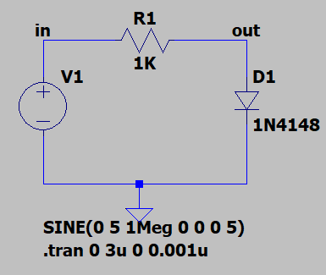

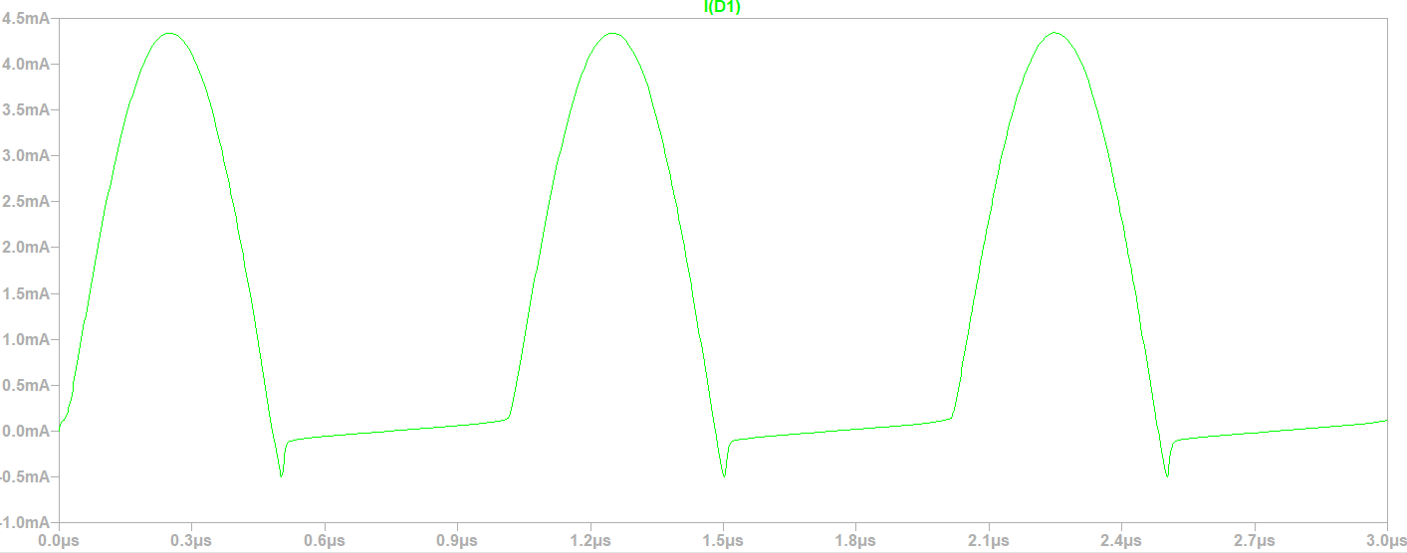

With the default parameters of the diode and using the sine generator with the parameters indicated in the circuit, it can be observed that when we are in the positive half-cycle of direct sine polarization of the source, then in the diode appear positive half-cycles of current with a sine shape. Whereas when you pass towards a negative half-cycle of reverse bias of the source, then in the diode appears, in terms of amplitude, a very small reverse current peak of very short duration that represents or is associated with the charge curve of a capacitor, but immediately afterwards it is observed that the current in the diode has a linear shape is and almost a cte and also almost zero during the half-cycle Source negative. We can say that diode rectifies or "clips" the negative half-cycles of the inverse signal but, not only in terms of voltage but also in terms of current. However, this rectification quality is affected by the working frequency of the diode.

**It is possible to conclude** that a diode at low frequencies, such as 50 Hz, can work as a rectifier, although it is not perfect since for a short time it conducts in reverse, that is, it allows a small part of the negative half-cycle of an alternating signal to pass through. This effect would be negligible at low frequencies. However, increasing the working frequency, such as 1MHz, would produce this undesired effect to a greater extent, which is not useful and would be more noticeable in RF (Radio Frequency) circuits, introducing distortions and noises.

b) **Analysis for input signal as sine by varying the joining capacity**:

We start with the following directive ".model 1N4148 D(Is=2.52n Rs=.568 N=1.752 Cjo=4p M=.4 tt=20n Iave=200m Vpk=75 mfg=OnSemi type=silicon)" to modify the diode parameters. Remembering that the default value of the junction capacity is Cj = 4 pF. Without changing the diffusion capacity, but changing the value of the junction capacity 5 times in 5 different values, we have the following graphs:

For Cj = 0.01 pF

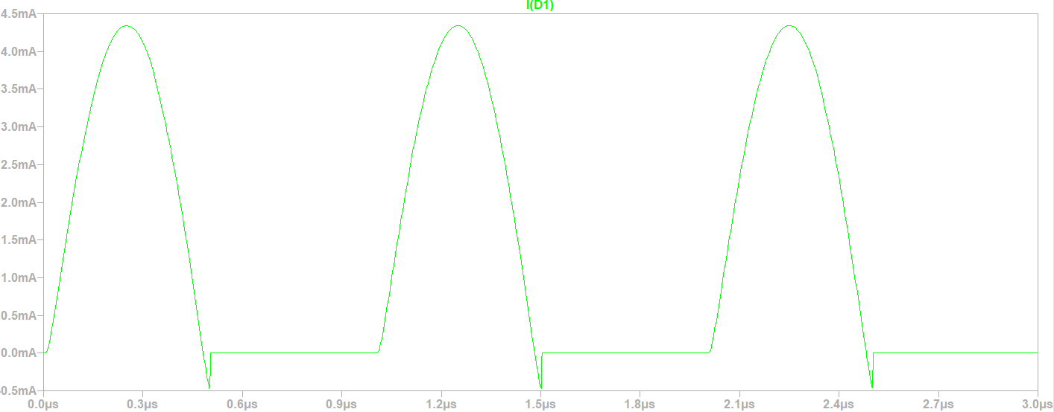

For Cj = 1 pF

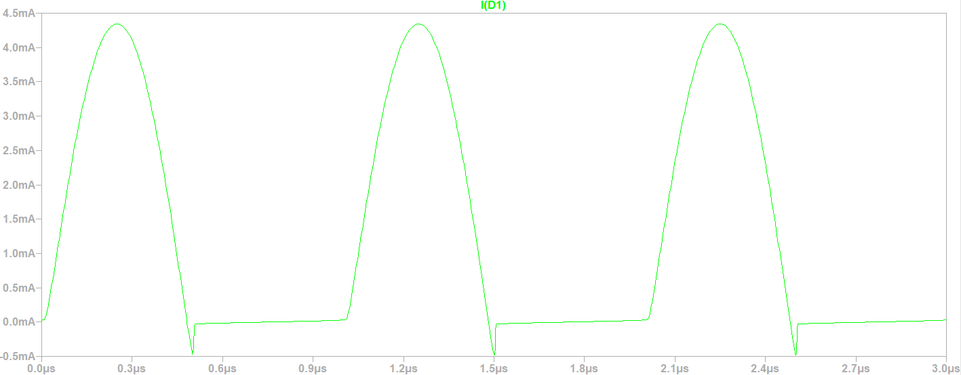

For Cj = 20 pF

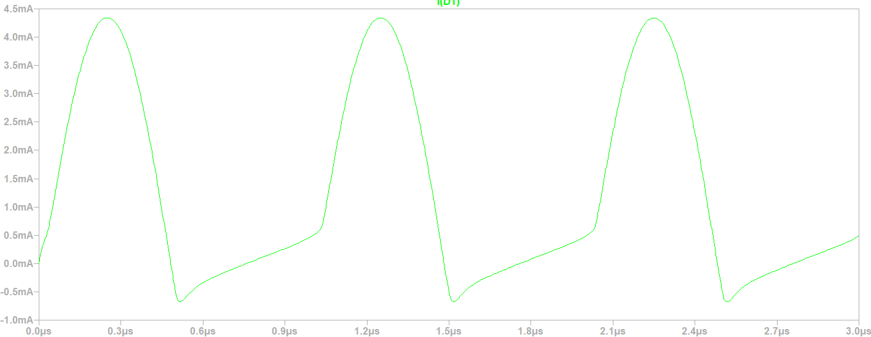

For Cj = 100 pF

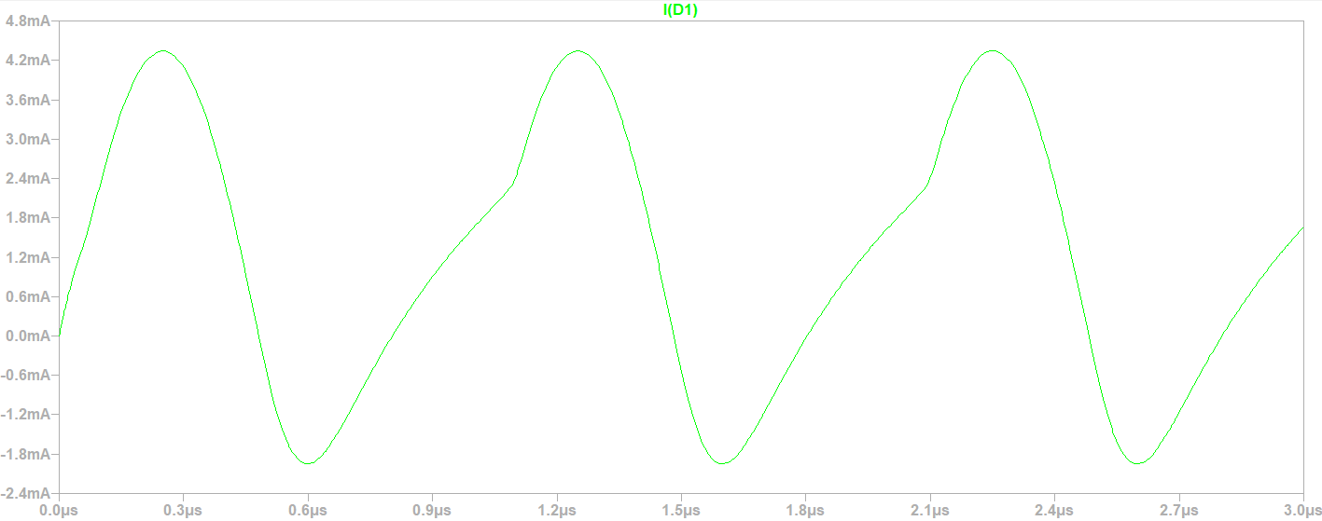

For Cj = 1 nF

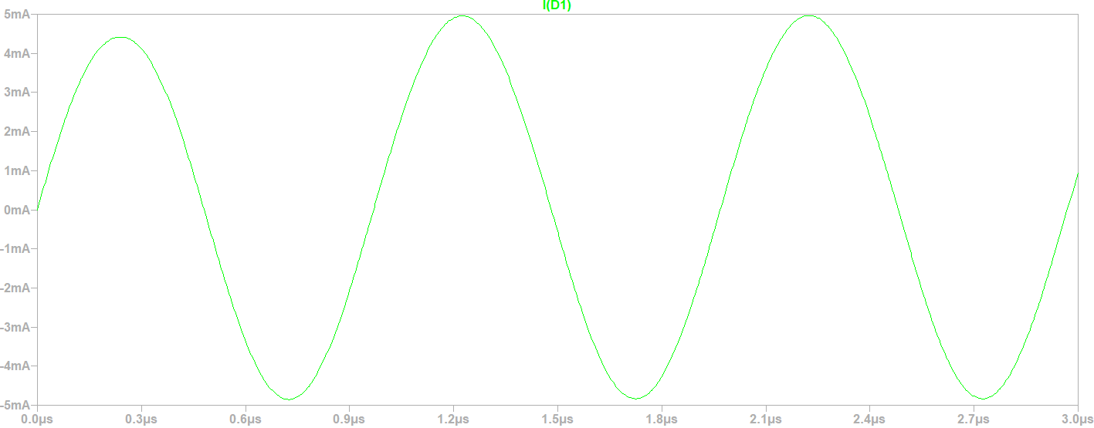

We observe that for junction capacity values less than Cj = 4 pF, the trimming of the reverse polarization negative half-cycles of the source is increasingly precise, further eliminating the reverse current peak with respect to its amplitude and duration time. So it allows the positive half-cycle of the input signal from the source to pass through better. It can be said that if Cj, then the diode tends to be a perfect rectifier. While for values greater than Cj = 4 pF, the cuts of the negative half-cycles worsen since the reverse current peak is enlarged in amplitude and duration time, such that for small values of the order of pF, this peak represents the load curve of a capacitor, in this case the capacitor would be the one formed internally at the junction PN that behaves similar to that of parallel plates with the the difference is that it stores charges in volume and not in flat plates, as well as that the width of the spatial charge area also varies. Additionally, for large values of the order of pF as well as of higher order, such as nF, we see that this inverse current peak increasingly resembles the sine shape of the negative half-cycle coming from the source until this behavior is completely achieved. On the other hand, positive current half-cycles are affected by suffering a deformation during the rise time when Cj is varying in a specific range of values, around 100 pF, a range for which the current peaks of negative half-cycles are going through a process of changes becoming more sinelidal. Subsequently, they are almost unaffected by the increase in Cj when it is very large, around 1 nF, since these positive half-cycles continue to pass the diode stage without any problem, maintaining almost no changes in their sine shape, amplitude and duration at the exit of the element. It can be said that if Cj , then the diode does not work as a rectifier, but lets the entire input signal through.

**In conclusion**, the diode for low junction capacities tends to be a perfect negative half-cycle rectifier allowing positive half-cycles to pass, although with small current peaks in amplitude and duration which make it negligible. Whereas, for high junction capacity, the diode simply does not work as a diode but as a closed key or cable since it lets the entire signal pass through without rectifying anything. This could be confused with it being in bad condition or broken, but it would not necessarily be that. This is evaluating at high frequencies as an example 1 MHz to 5 MHz.

c) **Analysis for input signal such as sine by varying the diffusion capacity**:

We start with the following directive ".model 1N4148 D(Is=2.52n Rs=.568 N=1.752 Cjo=4p M=.4 tt=20n Iave=200m Vpk=75 mfg=OnSemi type=silicon)" to modify the diode parameters. Remembering that the default value of the diffusion capacity is Cd associated with tt = 20 n sec. Without changing the junction capacity, but changing the value of the diffusion capacity through the tt about 5 times in 5 different values, we have the following graphs:

For tt = 0.01 n sec

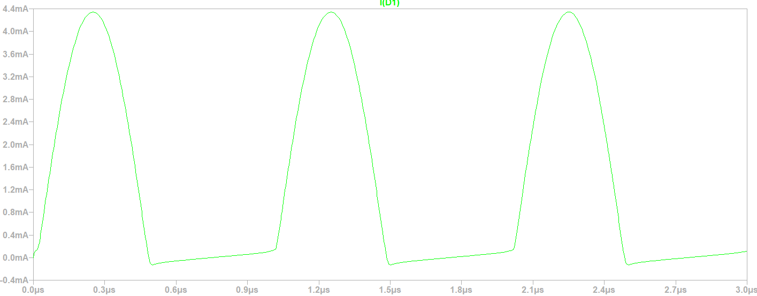

For tt = 1 n sec

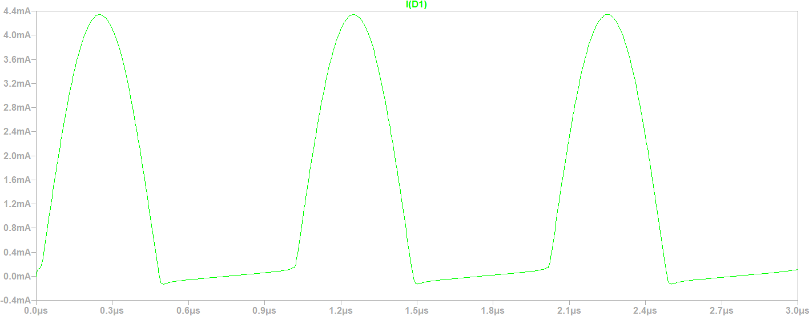

For tt = 100 n sec

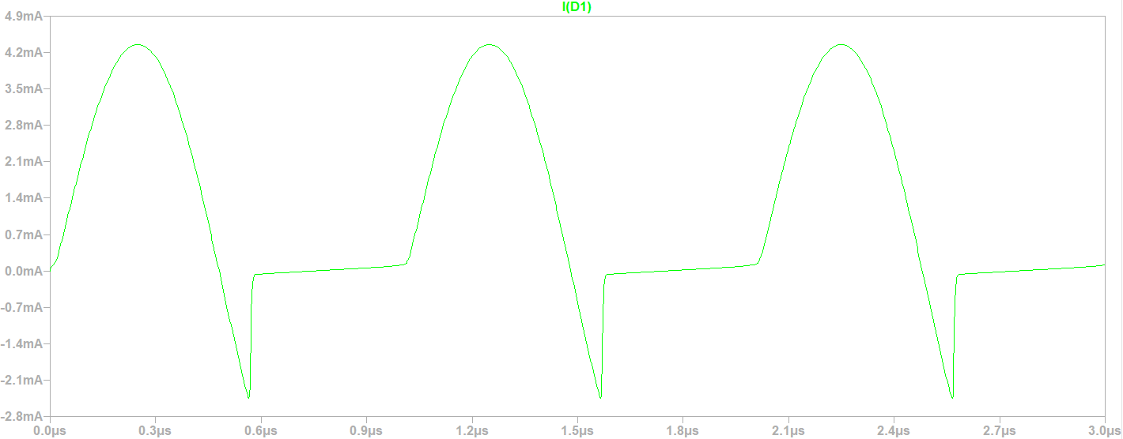

For tt = 500 n sec

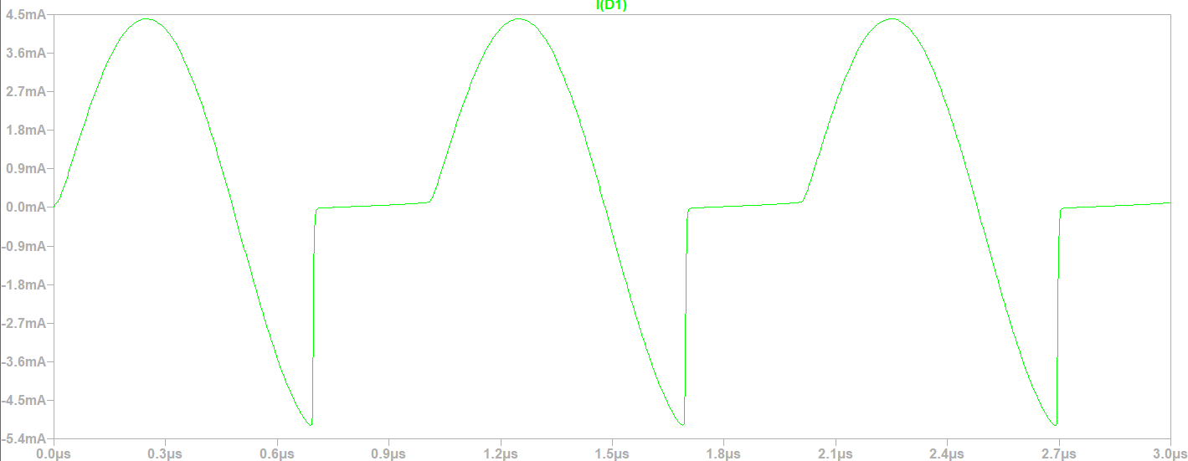

For tt = 1000 n sec

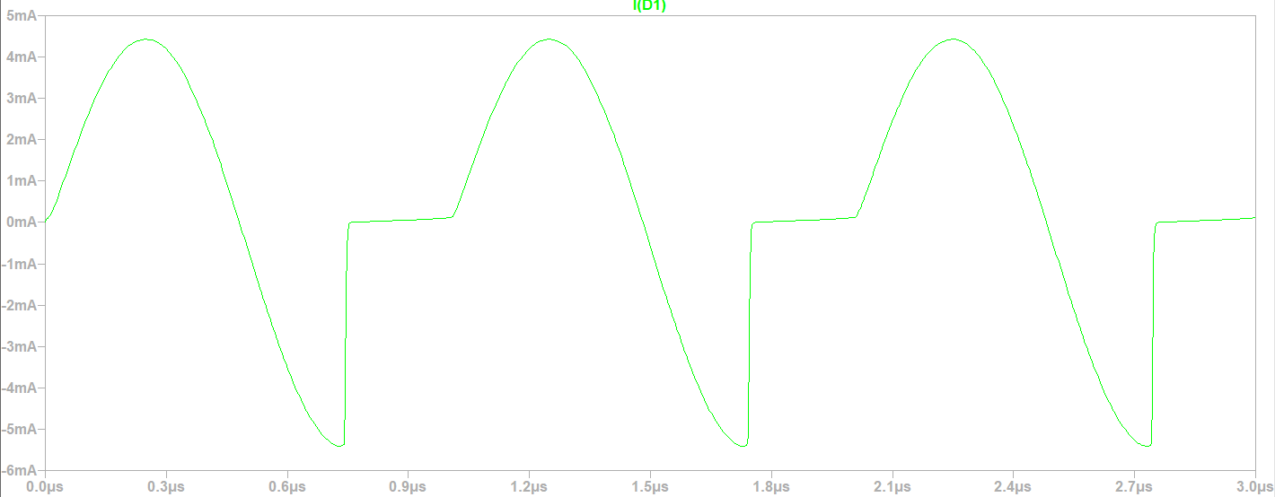

We see that for all the values of "tt", transition times each associated with a different diffusion capacity, current peaks of a certain amplitude and duration time appear when we go from a positive half-cycle of direct polarization to a negative one of reverse polarization. But then, in a negative half-cycle peak current stretch, there is an almost instantaneous jump between the negative maximum amplitude point toward the approximately 0 amplitude value. These current peaks are reverse-leakage such that they represent capacitor load curves. In this case, capacitor formed by the variation of accumulation of charges in volume in the neutral zones where such variation is subject to the diffusion process, that is, recombination of minority excess carriers from the area in which they were the majority and that now crossed the spatial charge zone, becoming minority and diffusing in the neutral zone of arrival.

In particular, for "tt" less than tt = 20 n sec by default, it happens that the inverse current peak has a very short amplitude and duration time such that the effect of the reverse peak is negligible, it has only the shape of a capacitor's load curve but then becomes a line, almost cte and of a value close to 0. Thus, the diode only conducts in the direct half-cycle and does not conduct in the reverse half-cycle by "clipping" or rectifying the signal in its negative half-cycles.

On the other hand, for values of "tt" greater than tt = 20 n sec by default, it is observed that the inverse current peak increases its amplitude until it is almost equal in modulus to the amplitude of the positive half-cycle. In turn, the duration of this inverse peak extends and increases as "tt" increases, that is, when the diffusion capacity increases. This results in a sine-shaped peak during the descent and a linear straight line of infinite slope on the ascent with a certain duration of duration. Then, after a certain time and during the negative half-cycle stretch, this peak disappears and the diode "clips" or rectifies the rest of the negative half-cycle signal until it transitions towards the positive half-cycle, this transition being sineidal.

We can think as a **conclusion** that as the diffusion capacity, through "tt", is reduced, then the diode behaves like a rectifier and especially if it tends to 0 that "tt" then it is a perfect rectifier. Whereas when "tt" increases, i.e., increases the diffusion capacity, then the diode behaves as a regulator of the duration of a reverse current peak of a periodic sine current signal in reverse polarization and that does not modify the duration time of the sine positive half-cycle, it only does so for the inverse half-cycle. This is evaluated at high frequencies, such as 1 MHz to 5 MHz

As a **general conclusion**, we can say that a diode behaves as a good rectifier at low frequencies while, at high frequencies, this rectification and its quality are affected and dependent on the joining and diffusion capacity. For an input pulse train signal, the variation in joining capacity implies a variation in the rectification quality of the negative half-cycles; while the variation of diffusion capacity results in the variation of the duty cycle of an inverse pulse in a negative half-cycle. Something similar happens for an input sine signal.

**Conclusion**

Throughout the work, it was possible to study the characteristic curve and the conduction threshold voltage for each type of diode, as well as the dynamic resistance for one of them, whose value was so small that in certain applications it is negligible while in others it influences. It was also possible to observe the effects of temperature on the behavior of the device where when this magnitude increases, then the conduction threshold voltage decreases. On the other hand, it was shown that in the software, when the parameters of junction and diffusion capacity vary during the application of a variable voltage, a variation in the width of the spatial charge zone is produced in theory, as well as the potential barrier and in turn a variation of the stored charge both in the spatial charge zone and in the neutral zones. This resulted in undesirable effects when trying to use a typical diode as a rectifier where depending on the capacity values, the rectifier was more or less accurate. It was concluded that even rectification could cease to exist as a desired functionality and that a kind of regulation effect of the work cycle of the reverse half-cycle appeared.